Comparing Mitosis and Meiosis

1. Mitosis and meiosis are two different types of cell division. Why does the human body need two different types of cell division?

2. When completed, this figure will summarize mitosis and meiosis in a cell with two pairs of homologous chromosomes. Follow the directions in the column on the right.

Label each column as either meiosis or mitosis.

In each cell, the DNA has been replicated and the chromosomes have condensed into sister chromatids. Label two sister chromatids.

Show how the two pairs of homologous chromosomes are lined up at the beginning of mitosis or meiosis.

In one of the cells, circle a pair of homologous chromosomes.

Show what has happened to the chromosomes as each cell prepares for cytokinesis.

The dotted line represents cytokinesis.

Show what has happened to the chromosomes as each cell prepares for cytokinesis.

Another cytokinesis

3a. This figure shows the human life cycle. Fill in each blank in the boxes.  3b. Explain how the cell cycle is part of the human life cycle. | 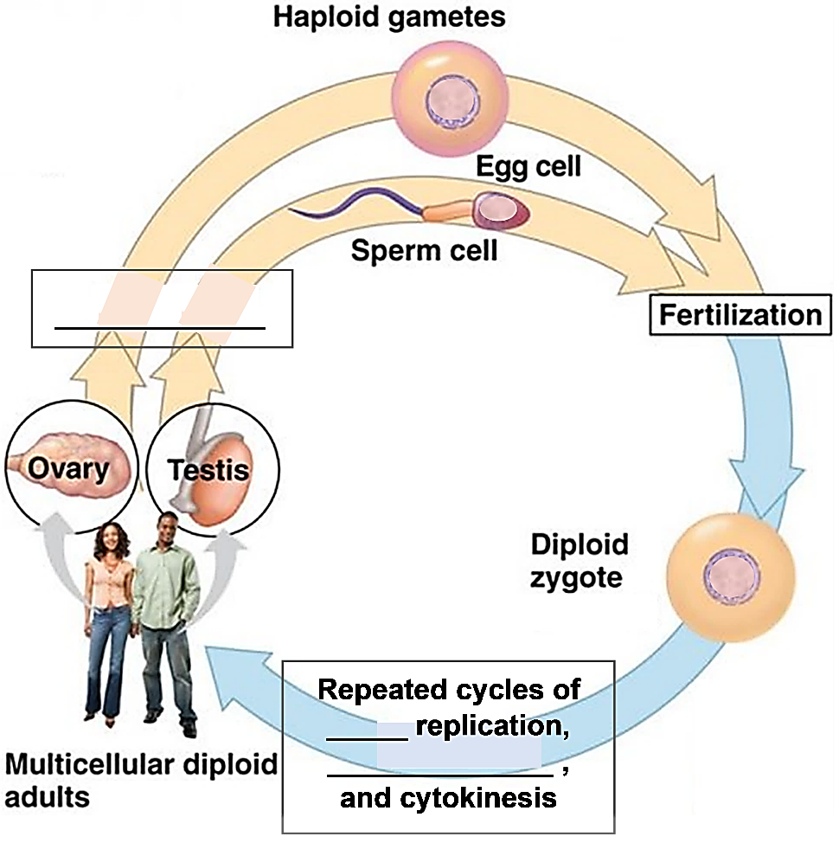

4. Describe at least three similarities between cell division by mitosis and cell division by meiosis.

5. Complete this table to describe some important differences between mitosis and meiosis.

Characteristic | Mitosis | Meiosis
Type of cells produced
# of cytokineses after a DNA replication
# of daughter cells produced
Are daughter cells genetically identical or different?

by Dr. Ingrid Waldron, Department of Biology, University of Pennsylvania, © 2022; this Student Handout and Teacher Notes with instructional suggestions are available at https://serendipstudio.org/exchange/bioactivities/MitosisMeiosisC

